**Q1. MapReduce Problem Statement Here, we have chosen the stock market dataset on which we have performed map-reduce operations. Following is the structure of the data. Kindlyfind the solutions to the questions below**

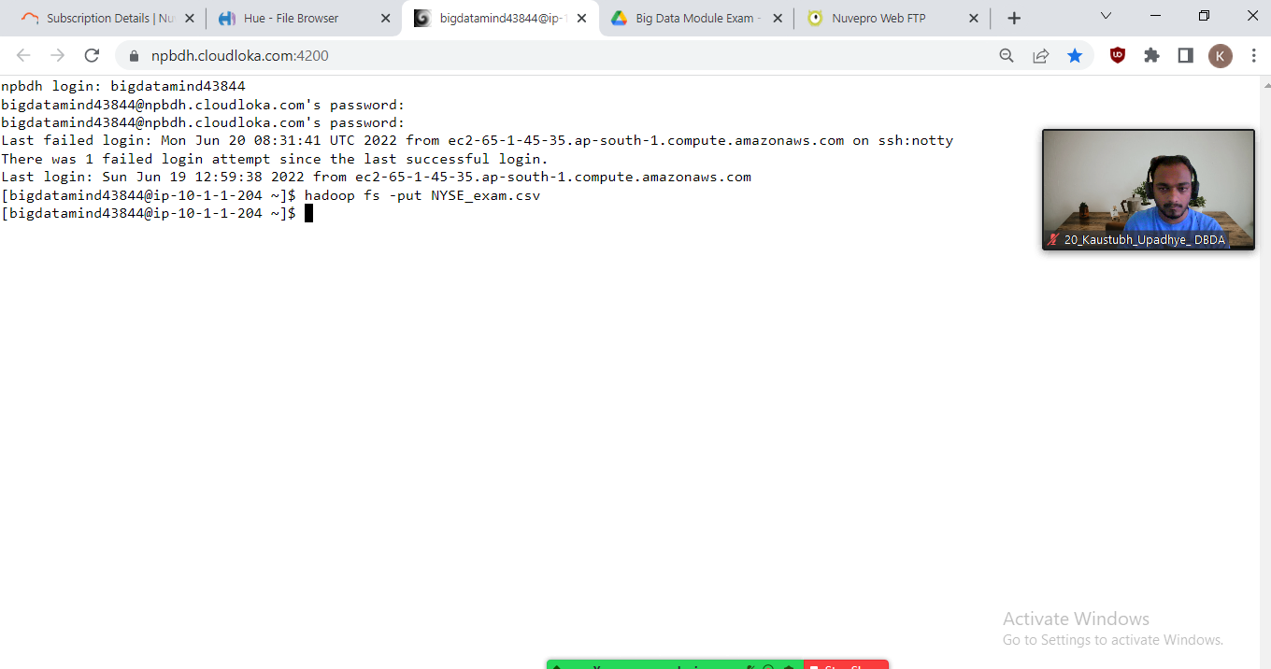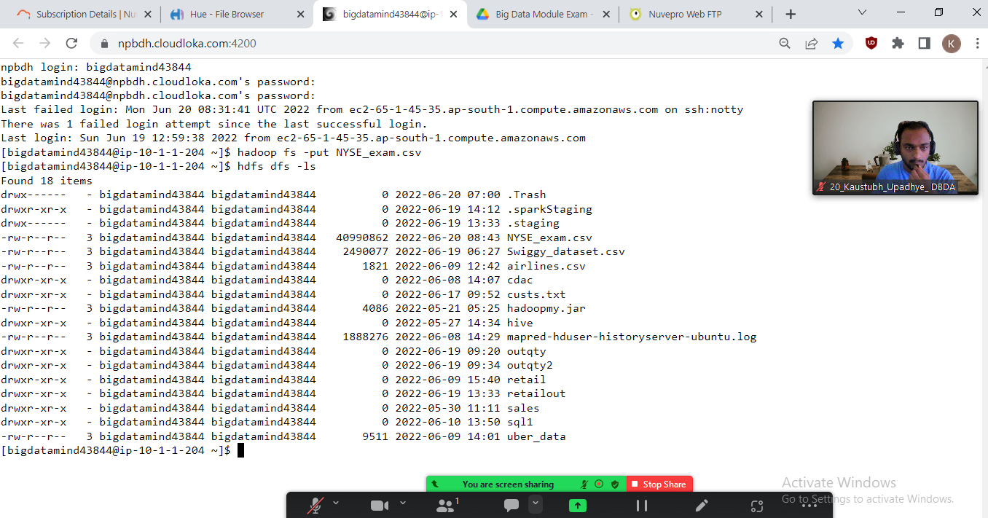

**#hadoop fs-ls**

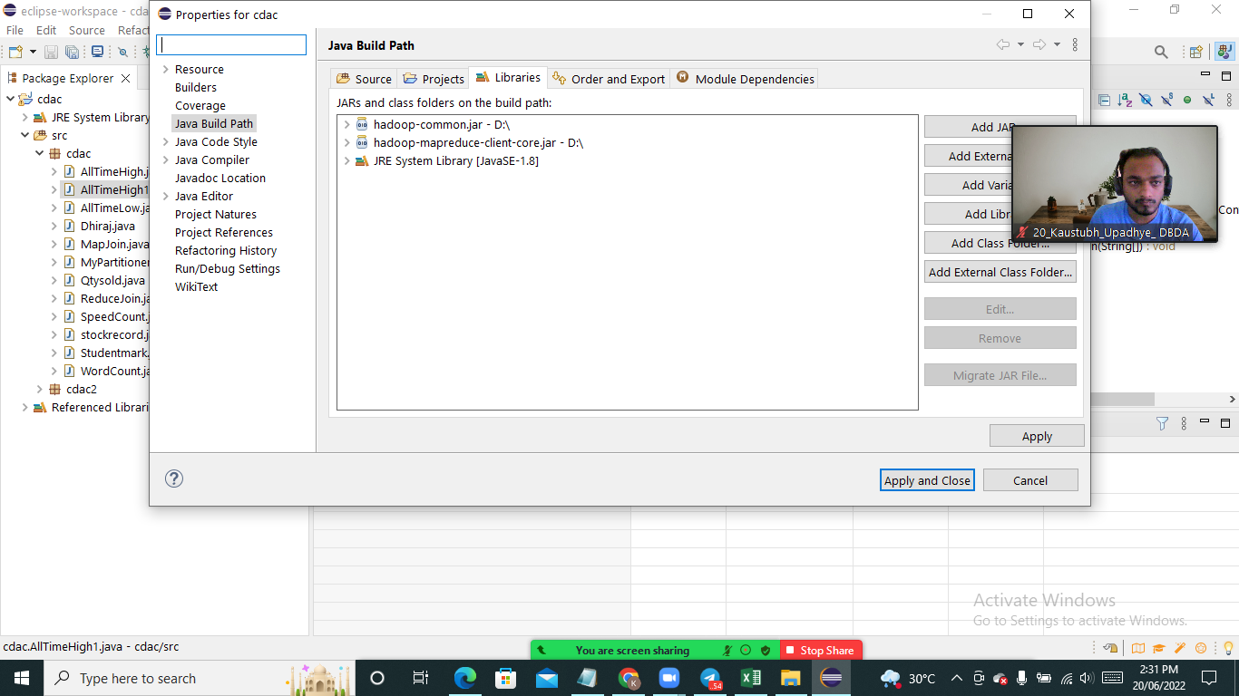

**#adding jars**

hadoop fs -put NYSE_exam.csv

Question 2 : Find all time High price for each stock

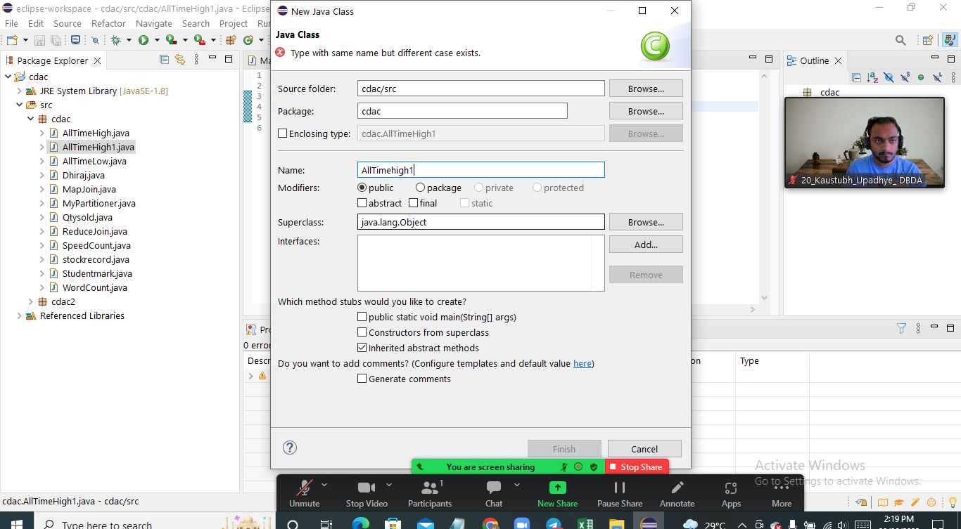

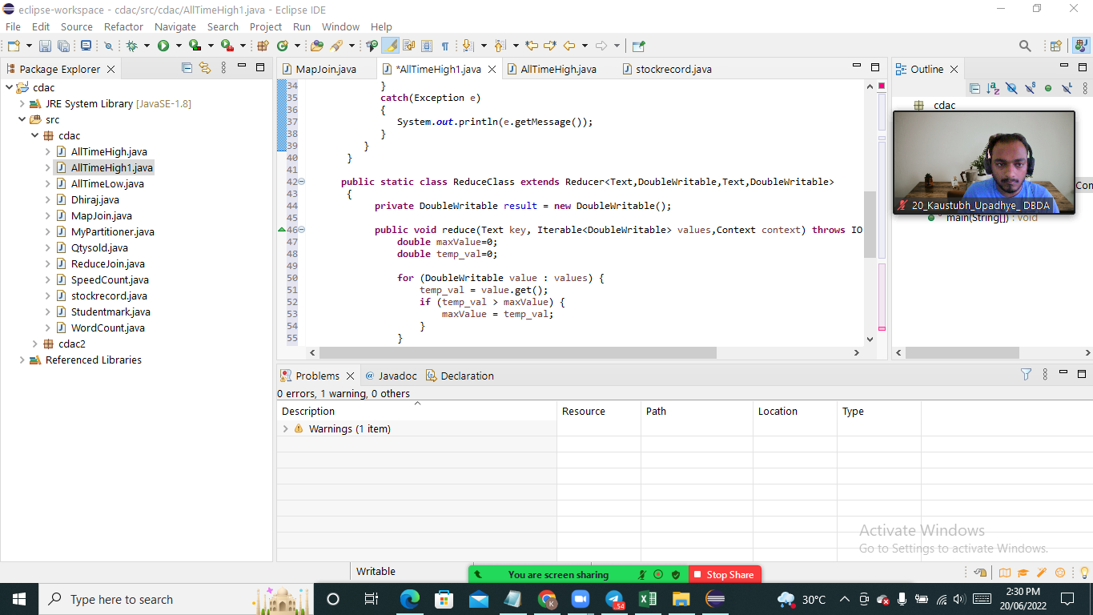

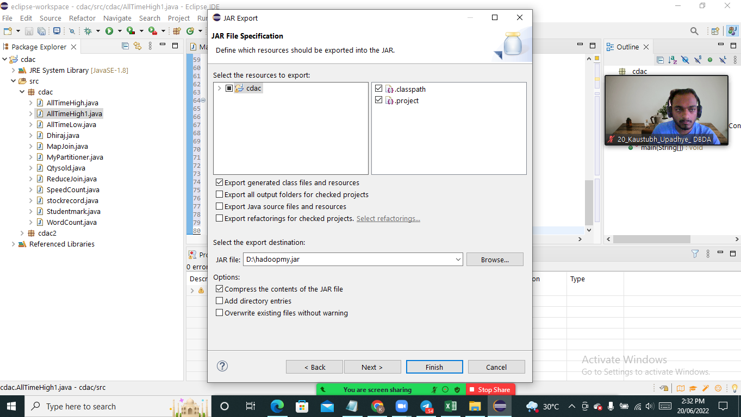

[bigdatamind43844@ip-10-1-1-204 ~]$ hadoop jar hadoopmy.jar cdac/AllTimeHigh1 NYSE_exam.csv cdac/alltimehigh_result

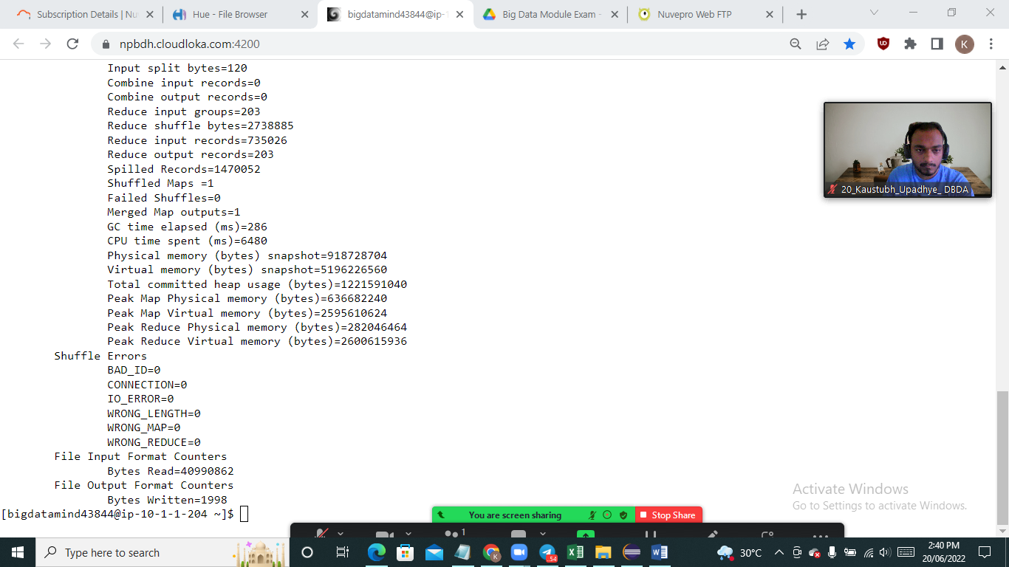

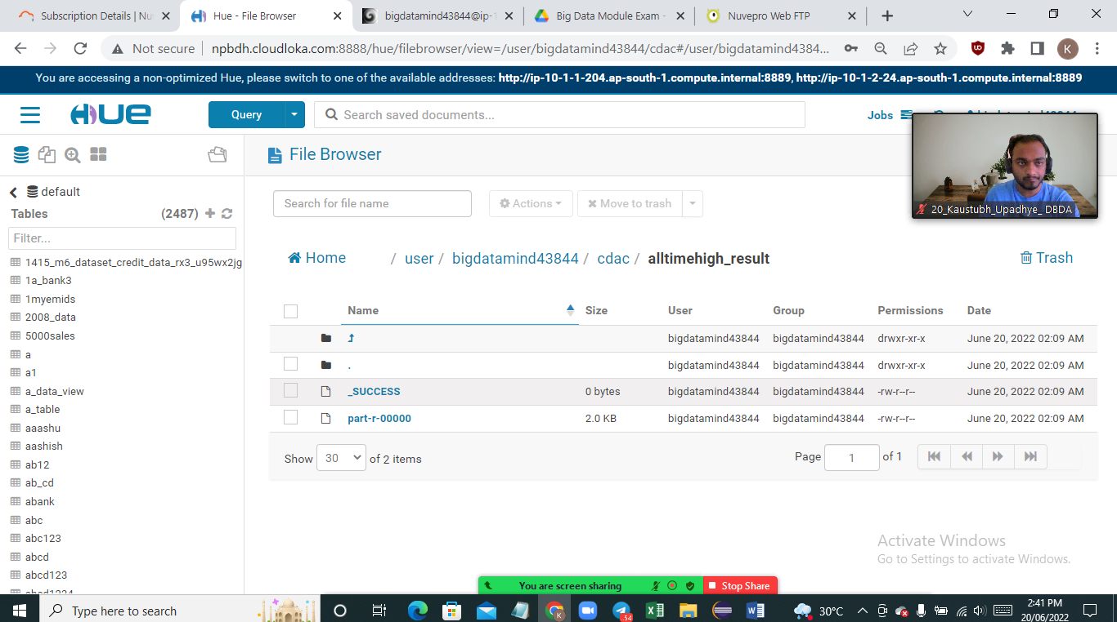

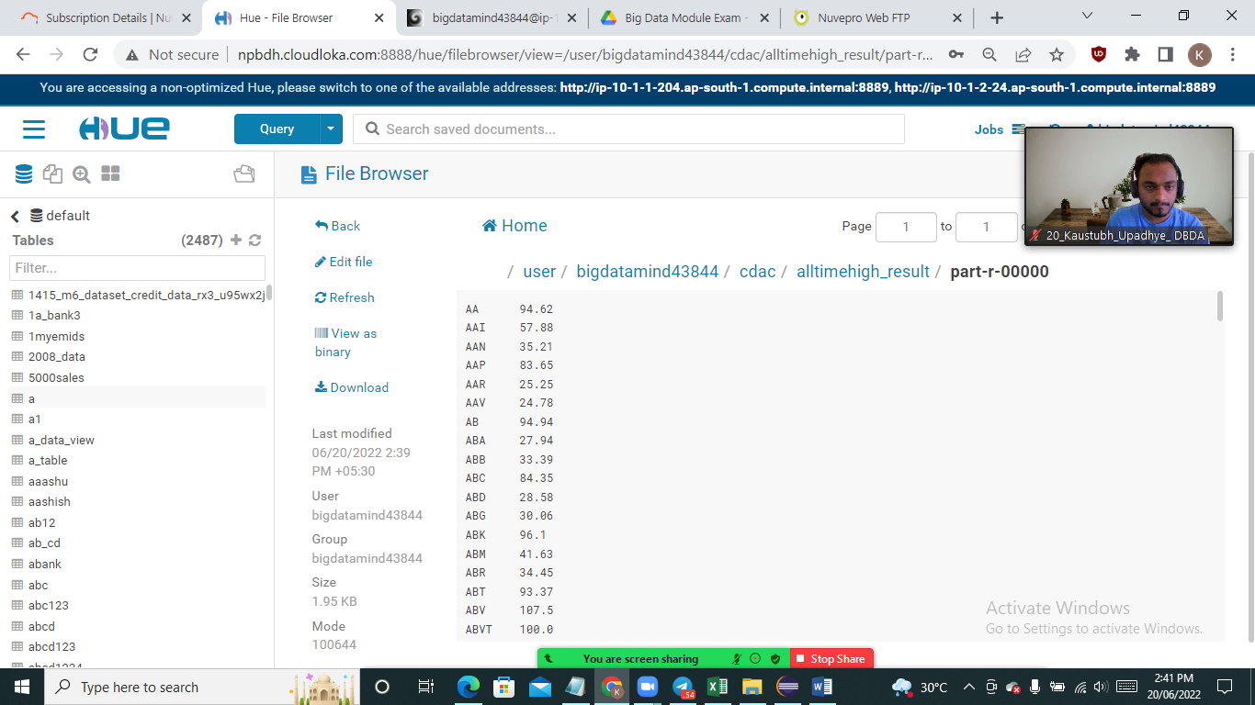**#Final output**

**Hive Please find the customer data set. cust id firstname lastname age profession**

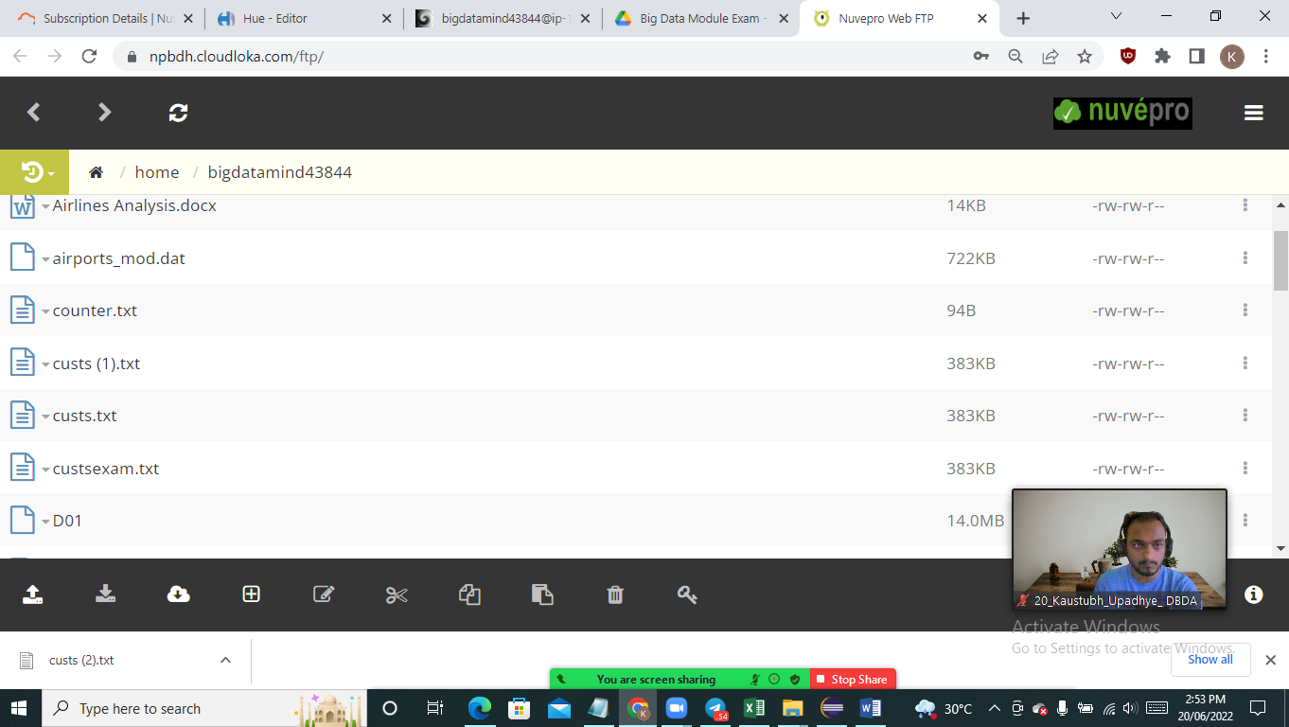

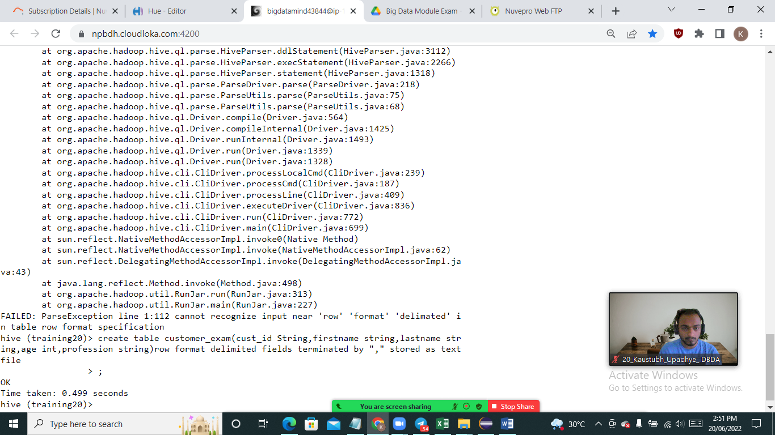

hive (training20)> create table customer_exam(cust_id String,firstname string,lastname str

ing,age int,profession string)row format delimited fields terminated by "," stored as text

file

> ;

OK

Time taken: 0.499 seconds

hive (training20)>

load data local inpath “/home/bigdatamind43844/custs_exam.txt” overwrite into table customer_exam

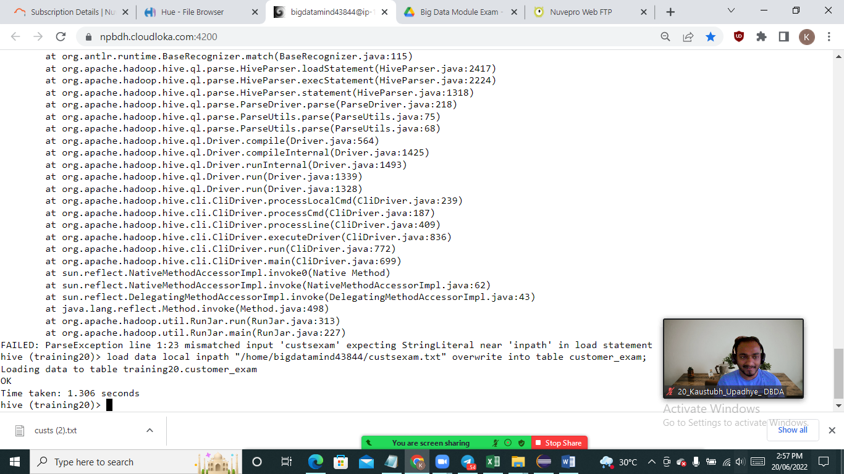

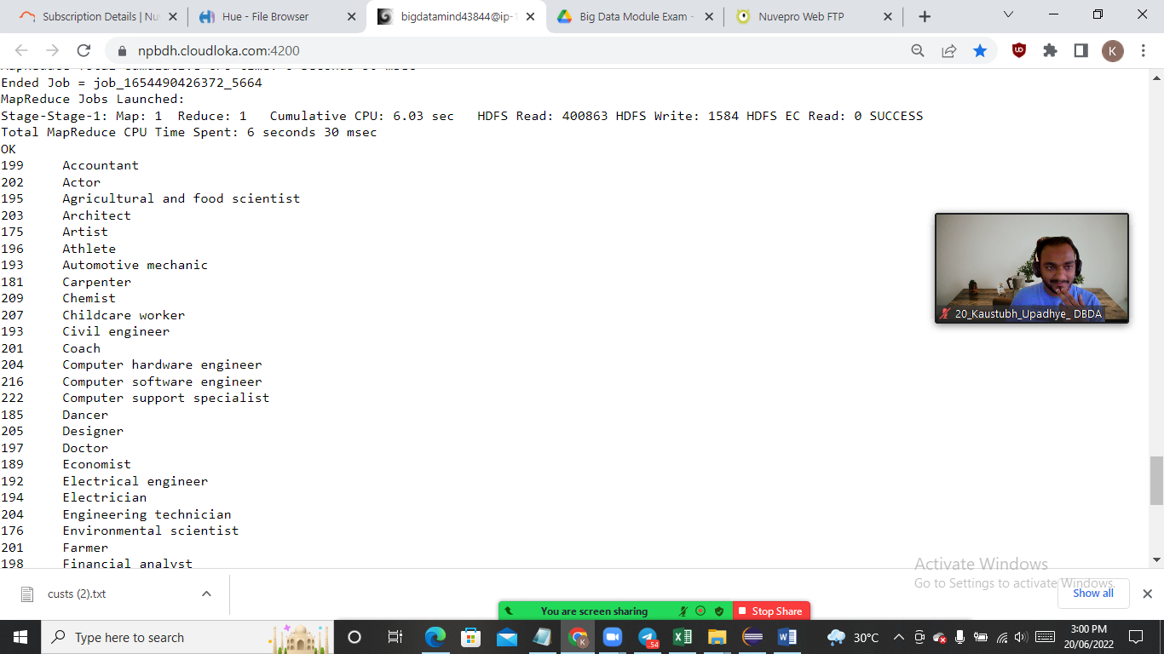

**Que1)Output Cutomer –**

**select count(cust_id)as Countof_customers,profession from customer_exam group by profession;**

**--------------------------------------------------------------------------------**

**2)Write a program to find the top 10 products sales wise**

Loading data to table training20.txnrecords_exam

OK

Time taken: 0.742 seconds

hive (training20)> **select product,sum(amount) as total from txnrecords_exam group by product order by total limit 10;**

Query ID = bigdatamind43844_20220620094318_3b84add4-739d-4304-8de9-b6cfca81885c

Total jobs = 2

Launching Job 1 out of 2

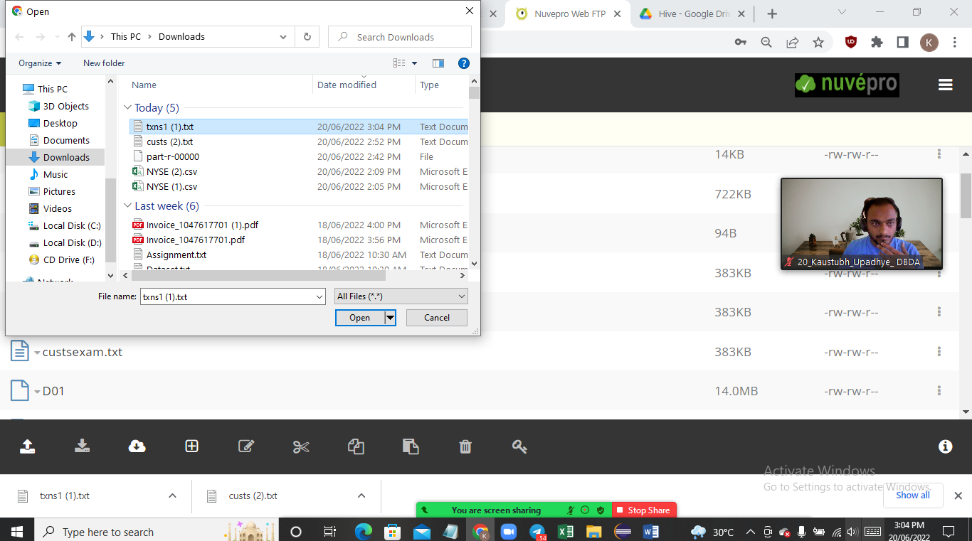

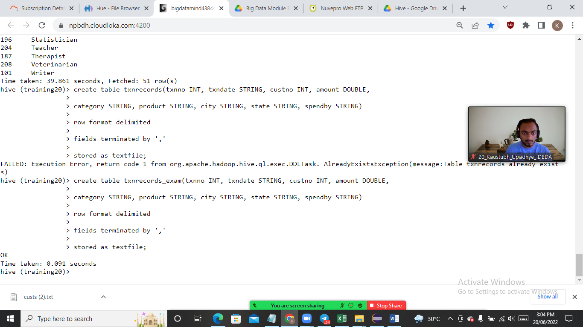

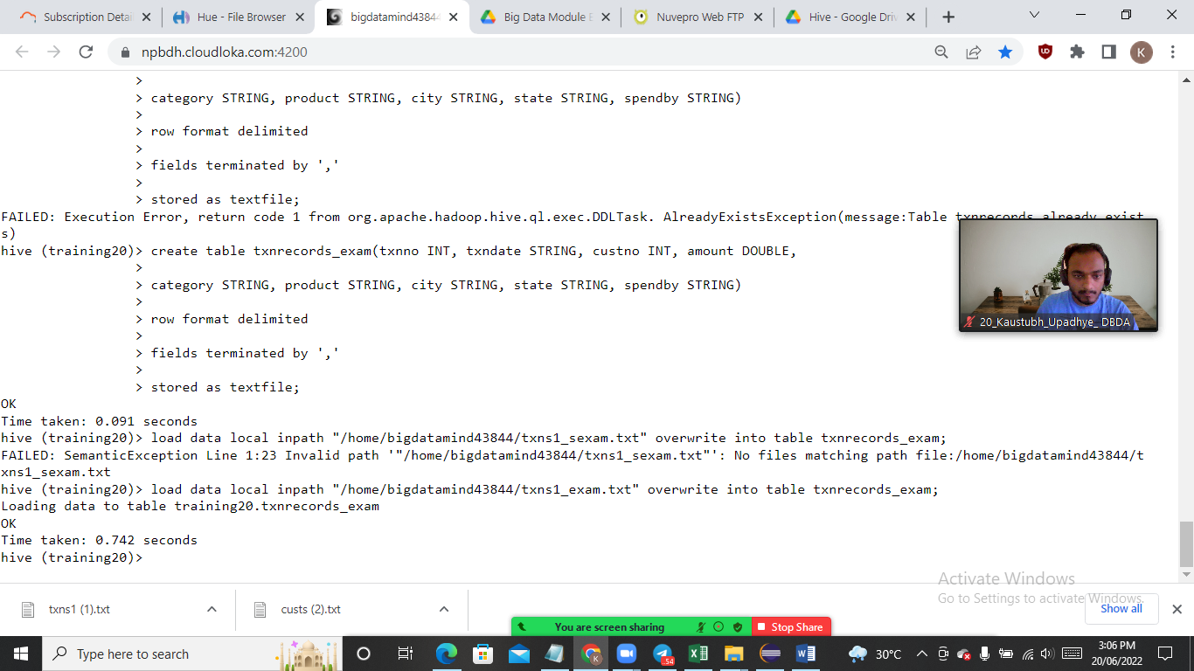

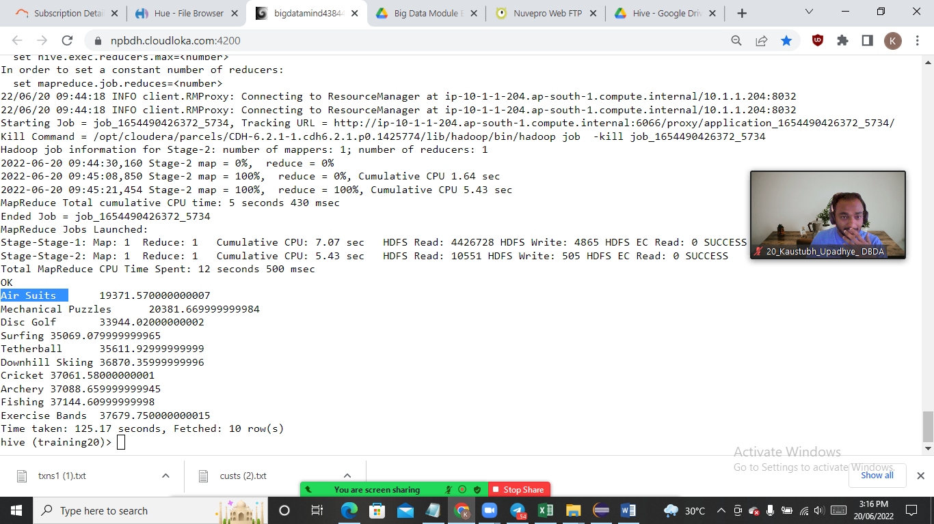

**Output –Que 2)**

**3) Write a program to create partiioned table on category**

hive> set hive.cli.print.current.db=true;

set hive.exec.dynamic.partition=true;

hive (default)> use training20;

create table txnrecs_part(txnno INT, txndate STRING, custno INT, amount DOUBLE,

product STRING, city STRING, state STRING, spendby STRING)

partitioned by (category STRING)

row format delimited

fields terminated by ','

stored as textfile;

INSERT OVERWRITE TABLE txnrecs_part PARTITION(category) select txn.txnno, txn.txndate,txn.custono, txn.amount,txn.product,

> txn.city,txn.state, txn.spendby, txn.category from txnrecords txn DISTRIBUTE By category;

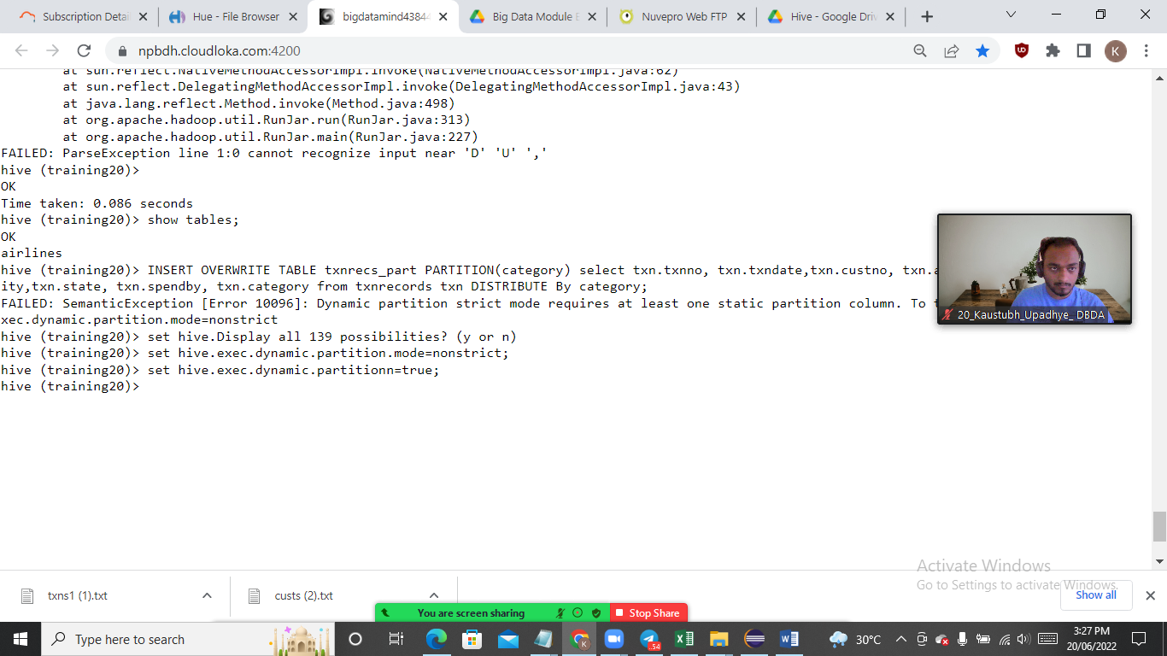

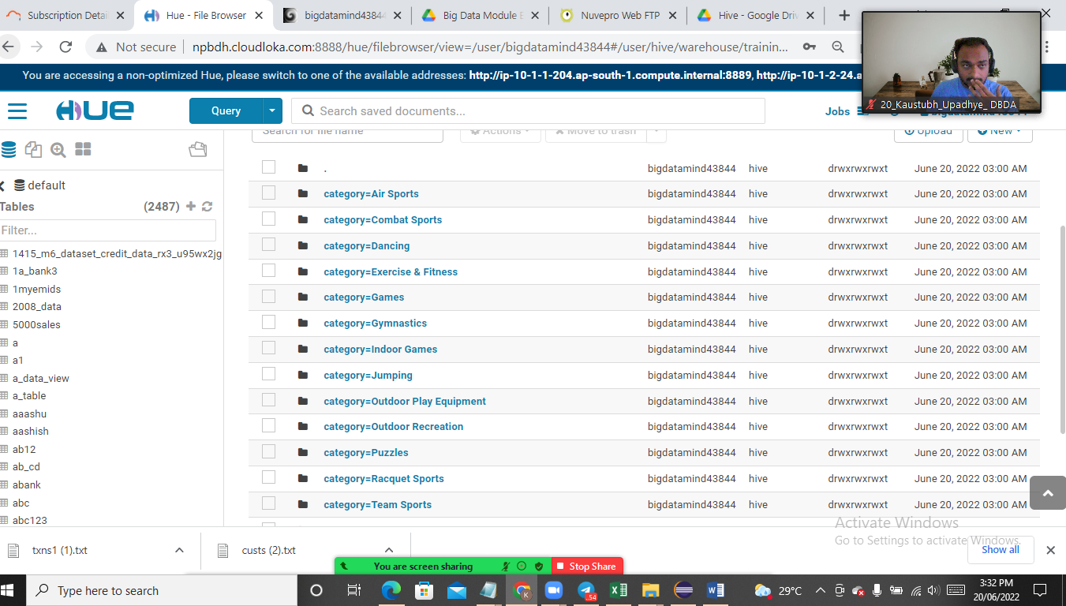

**QUESTION 3 [15 marks] PySpark Please find the AIRLINES data set Year Quarter Average revenue per seat Total number of booked seats**

**1) What was the highest number of people travelled in which year?**

**2) Identifying the highest revenue generation for which year**

**3) Identifying the highest revenue generation for which year and quarter (Common group)**

**Que1)**

airline_rdd=sc.textFile('/user/bigdatamind43827/exam/airlines.csv')

rdd1=airline_rdd.map(lambda a: a.encode("ascii","ignore"))

array_rdd=rdd1.map(lambda a : a.split(','))

header=array_rdd.first()

rdd2=array_rdd.filter(lambda a : a!= header)

key_value2=rdd2.map(lambda a : (a[0], float(a[3]) ))

add_total2=key_value2.reduceByKey(lambda a,b : a+b)

sortbyval2=add_total2.sortBy(lambda a: -a[1])

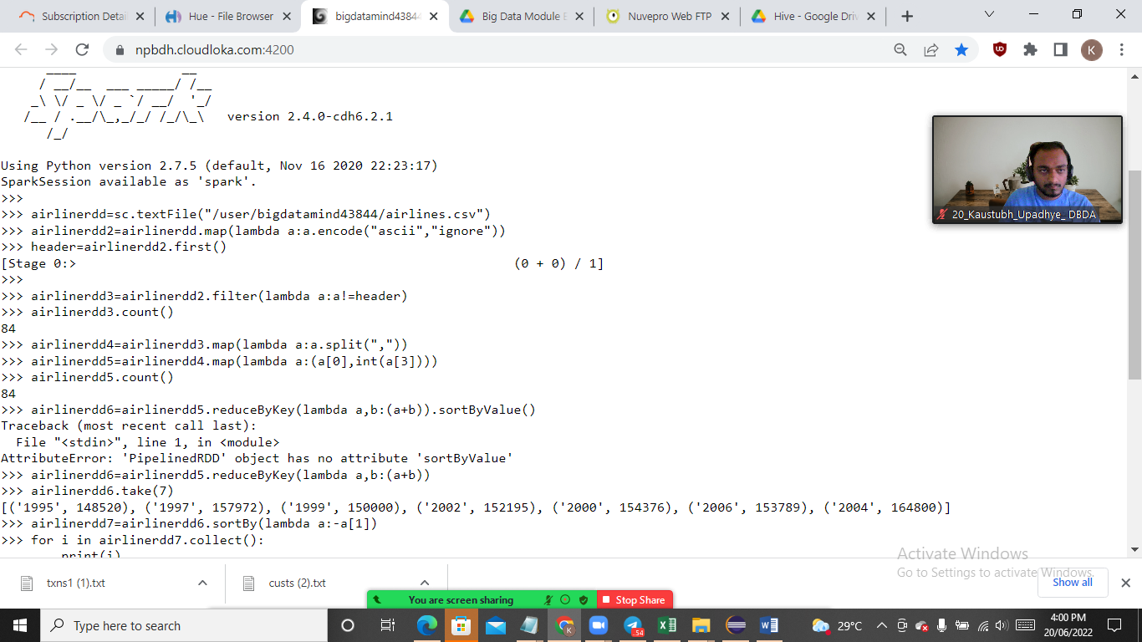

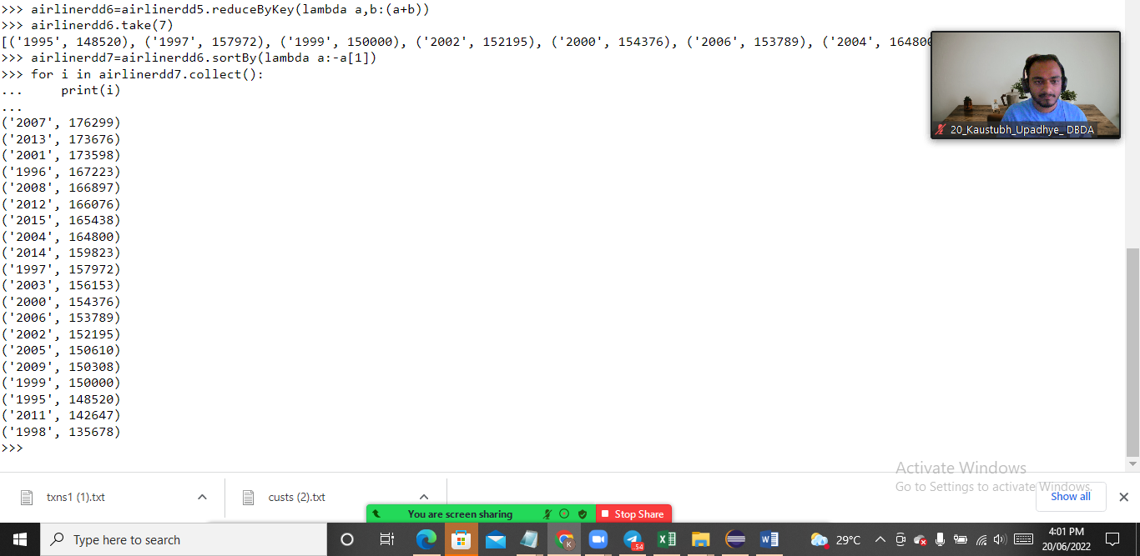

Q2) Identifying the highest revenue generation for which year

==>

airline_rdd=sc.textFile('/user/bigdatamind43827/exam/airlines.csv')

rdd1=airline_rdd.map(lambda a: a.encode("ascii","ignore"))

array_rdd=rdd1.map(lambda a : a.split(','))

header=array_rdd.first()

rdd2=array_rdd.filter(lambda a : a!= header)

key_value=rdd2.map(lambda a : (a[0], float (a[2]) * int (a[3]) ) )

add_total=key_value.reduceByKey(lambda a,b : a+b)

sortbyval=add_total.sortBy(lambda a: -a[1])

('2013', 66363208.71)

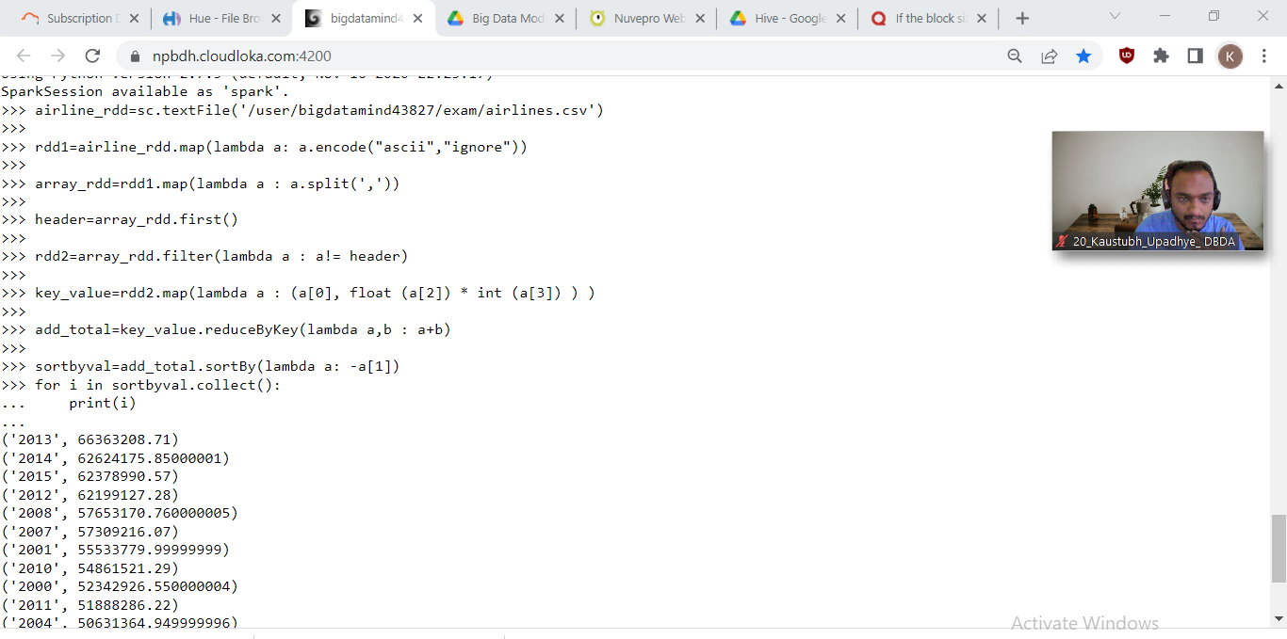

Q3)) Identifying the highest revenue generation for which year and quarter (Common

group)

==>

airline_rdd=sc.textFile('/user/bigdatamind43827/exam/airlines.csv')

rdd1=airline_rdd.map(lambda a: a.encode("ascii","ignore"))

array_rdd=rdd1.map(lambda a : a.split(','))

header=array_rdd.first()

rdd2=array_rdd.filter(lambda a : a!= header)

key_value2=rdd2.map(lambda a : ((a[0]+" "+a[1]), float(a[2])*int(a[3]) ))

add_total2=key_value2.reduceByKey(lambda a,b : a+b)

sortbyval2=add_total2.sortBy(lambda a: -a[1])

